# Explorer++

# Help Manual

Version 1.0

Last Updated: 18/07/2010

## K:\Releases\screenshot_1.pngKeyboard Shortcuts

|  |  |
| --- | --- |
| **Command** | **Shortcut** |
| **Navigation** | |
| Back | Alt+Left Arrow |
| Forward | Alt+Right Arrow |
| Up | Backspace |
| Refresh | F5  Ctrl+R |
| **Editing** | |
| Copy | Ctrl+C |
| Cut | Ctrl+X |
| Delete | Delete |
| Delete Permanently | Shift+Delete |
| Paste | Ctrl+V |
| **Selection** | |
| Select All | Ctrl+A |
| Invert Selection | Ctrl+I |
| Select None | Ctrl+Shift+N |
| Wildcard Select | Ctrl+Shift+S |
| Wildcard Deselect | Ctrl+Shift+D |
| **Windows & Tabs** | |
| Close Tab | Ctrl+W  Ctrl+F4 |
| Close Window | Alt+F4 |
| New Tab | Ctrl+T |
| New Window | Ctrl+N |
| Next Tab | Ctrl+Tab  Ctrl+Page Down |
| Previous Tab | Ctrl+Shift+Tab  Ctrl+Page Up |
|  |  |
|  |  |

## Options Dialog

To open the Options dialog, select Tools->Options...

## General tab

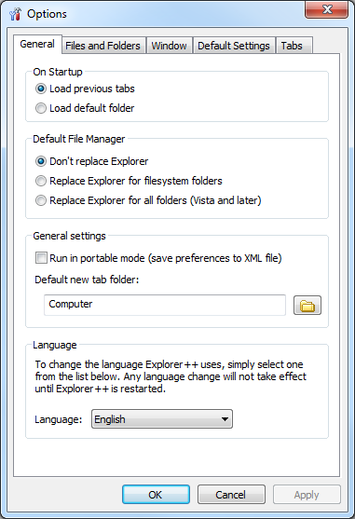

### On Startup

* **Load previous tabs:** Loads each of the tabs that was open when Explorer++ was last closed.
* **Load default folder:** Loads the default new tab folder.

### Default File Manager

* **Don't replace Explorer:** This is the default option. Using this option, Explorer++ will **not** be set as the default manager.
* **Replace Explorer for filesystem folders:** Replaces Windows Explorer for all filesystem folders. This includes folders such as C:\ and C:\Windows, for example, but not ones such as the Control Panel, or Recycle Bin.
* **Replace Explorer for all folders:** This option is only available in Windows Vista and later. If selected, Explorer++ will replace Windows Explorer for **all** folders. This includes folders such as the Control Panel and Recycle Bin, as well as all other folders within the system.

### General Settings

* **Run in portable mode (save preferences to XML file):** If set, Explorer++ will save all settings to a file named **config.xml**. This file can then be moved with Explorer++, allowing it to be fully portable.
* **Default new tab folder:** Controls the folder that is shown when opening a new tab.

### Language

* **Language:** Sets the language used by Explorer++. To use a different language, the required translation DLL must be in the same folder as Explorer++.

## Files and Folders tab

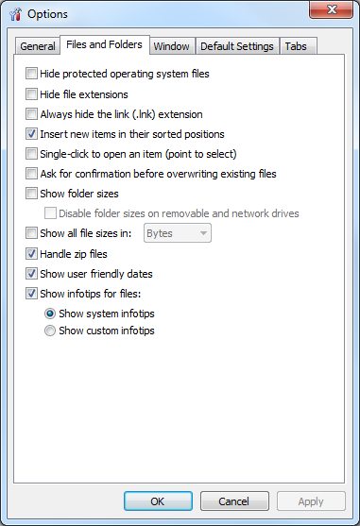

* **Hide protected operating system files:** If selected, Explorer++ will not show files that have the **system** attribute set.
* **Hide file extensions:** If selected, all file extensions will be hidden. A file such as 'test.txt' will simply be shown as 'test'.
* **Always hide the link (.lnk) extension:** If selected, the .lnk extension will always be hidden.
* **Insert new items in their sorted positions:** If selected, new items will be inserted into their correct positions, depending on the current sort order that is used. If not selected, items will be inserted at the end of the listview.
* **Single-click to open an item (point to select):** If selected, items will be opened with a single click, otherwise items will open when double clicked.
* **Ask for confirmation before overwriting existing files:** If selected, Explorer++ will show a confirmation dialog before overwriting existing files.
* **Show folder sizes:** If selected, Explorer++ will show folder sizes, both in (1) the display window, when a folder is selected, and (2) the size column in details view.
  + **Disable folder sizes on removable and network drives:** To improve performance, this option stops Explorer++ from showing folder sizes on either removable or network drives.
* **Show all folder sizes in:**
* **Handle zip files:**
* **Show user friendly dates:**
* **Show infotips for files:**

## Window tab

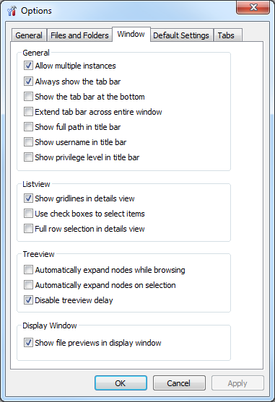

### General

* **Allow multiple instances:** Indicates whether Explorer++ can have multiple instances (i.e. multiple processes) open at the same time. If you have Explorer++ set as the default file manager, checking this option can be useful, as it will cause all folders to open within the same Explorer++ window.
* **Always show the tab bar:** If this setting is unchecked, and there is only one tab, the entire tab bar will be hidden. On smaller screens, this may be an advantage, since it will allow the listview to show more items.
* **Show the tab bar at the bottom:**
* **Extend the tab bar across the entire window:**
* **Show full path in title bar:** Normally, only the display name for a folder will be shown in the title bar. So, the title bar will show 'Windows' when browsing into C:\Windows, for example. If this options is checked, the entire path will be shown. For C:\Windows, the title bar will display 'C:\Windows'.
* **Show username in title bar:**
* **Show privilege level in title bar:**

### Listview

## Default Settings tab

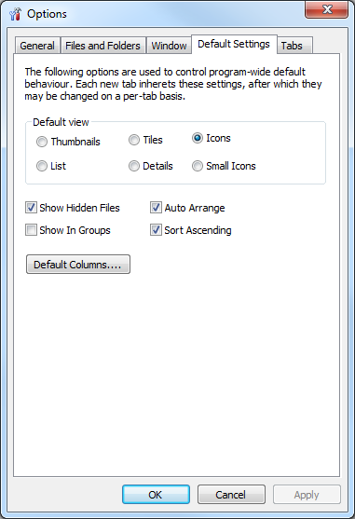

## Tabs tab

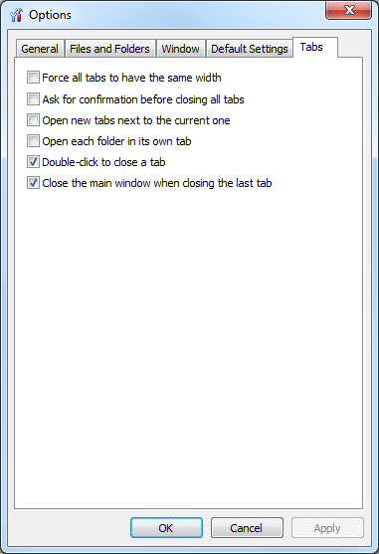

## Technical FAQ

* **What language is Explorer++ written in?**Explorer++ is written in C++, and makes direct use of the native Windows API.